# Changes in Trust Pay flow to accommodate policy changes

Goal

Improvement in seller experience.

## Background info

Current Trust Pay Policy

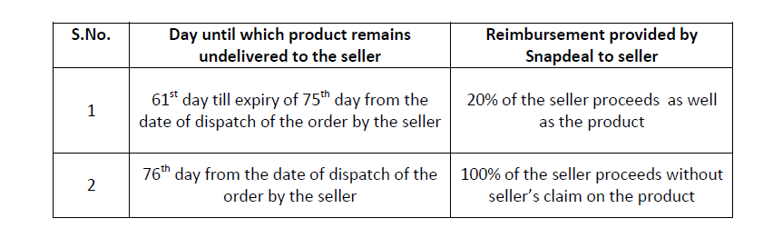

New Trust Pay Policy

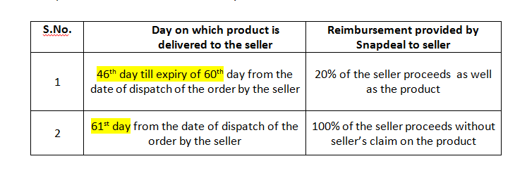

Change: - If the shipped date of the sub order is on or after policy launch date then on those sub orders trust pay would be applicable as per new policy whereas for sub orders whose shipped date is before policy launch date would be applicable for trust pay as per old policy.

## Use cases

|  |  |  |  |
| --- | --- | --- | --- |
| Sno. | User Story | Details | Component |
| 1. | As a seller once my return is delivered I should be applicable for 20% trust pay. | Policy change date is x date   1. Shipped Date >= x    1. Return delivered Date – Shipped Date (both status dates) >45 and <=60   THEN: - 20% trust pay should be paid.   1. Shipped Date < x    1. Return delivered Date – Shipped Date (both status dates) >60 and <=75 days   THEN: - 20% trust pay should be paid.  NOTE: All the checks placed at ERP end should work for both these cases. | ERAS, ERP |
| 2. | As a seller once the return is delivered I should be applicable for 100% trust pay. | Policy change date is x date   1. Shipped Date >= x    1. Return delivered Date – Shipped Date (both status dates) >=61 days   THEN: - 100% trust pay should be paid.   1. Shipped Date < x    1. Return delivered Date – Shipped Date (both status dates) >=76 days   THEN: - 100% trust pay should be paid.  NOTE: - All the checks placed at ERP end should work for both these cases. | ERAS, ERP |
| 3. | Business can specify the policy change date in a configurable way. | * System should maintain the date from which new policy would be applicable. * This date should be configurable. Can be changes without requirement of any release. * Date would be used to decide whether old or new trust pay policy is applicable on a specific sub order. | ERAS |
| 4. | Apart from the days after which trust pay policy kicks in, nothing else should be changed in the automation logic. | * All shipping, RMS statuses/events used in trust pay should remain same * All % payouts and the base used for payouts will remain same as before. * All ERP checks on trust pay would remain same as before. | ERAS, ERP |

**ERP Requirements from ERAS:-**

|  |  |  |
| --- | --- | --- |
| Day Range | Type | Transaction type |
| 45to60 | COD | COD Trustpay 45to60 |
| Above60 | COD | COD Trustpay above60 |
| 45to60 | NCOD | NCOD Trustpay 45to60 |
| Above60 | NCOD | NCOD Trustpay above60 |

There is no change in the field details except Transaction type name.



Validation to be applied in the ERP:-

1. If transactions under COD/NCOD Vendor Invoice and COD/NCOD return to Vendor transaction types are not exists for the suborder, then Trust pay transaction will not be processed.
2. If the payments already processed in the Seller Compensation or RTO Conflict or Other Trustpay, then trust pay transaction will not be processed.
3. If transaction comes with negative balance in the COD + Wallet cases, then transaction will be created under below transaction type.
4. Validation requried – Trust pay and Seller compensation pushed by ERAS should match with manually uploaded records in any trust pay and compensation types and shall not process the same and vice versa.
5. For old Trust pay reversal transaction types and new policy reversal transactions types also should be part of validation and also should be enable for user.

|  |  |  |
| --- | --- | --- |
| Day Range | Type | Transaction type |
| 45to60 | COD | COD Trustpay 45to60 DM |
| Above60 | COD | COD Trustpay above60 DM |
| 45to60 | NCOD | NCOD Trustpay 45to60 DM |
| Above60 | NCOD | NCOD Trustpay above60 DM |